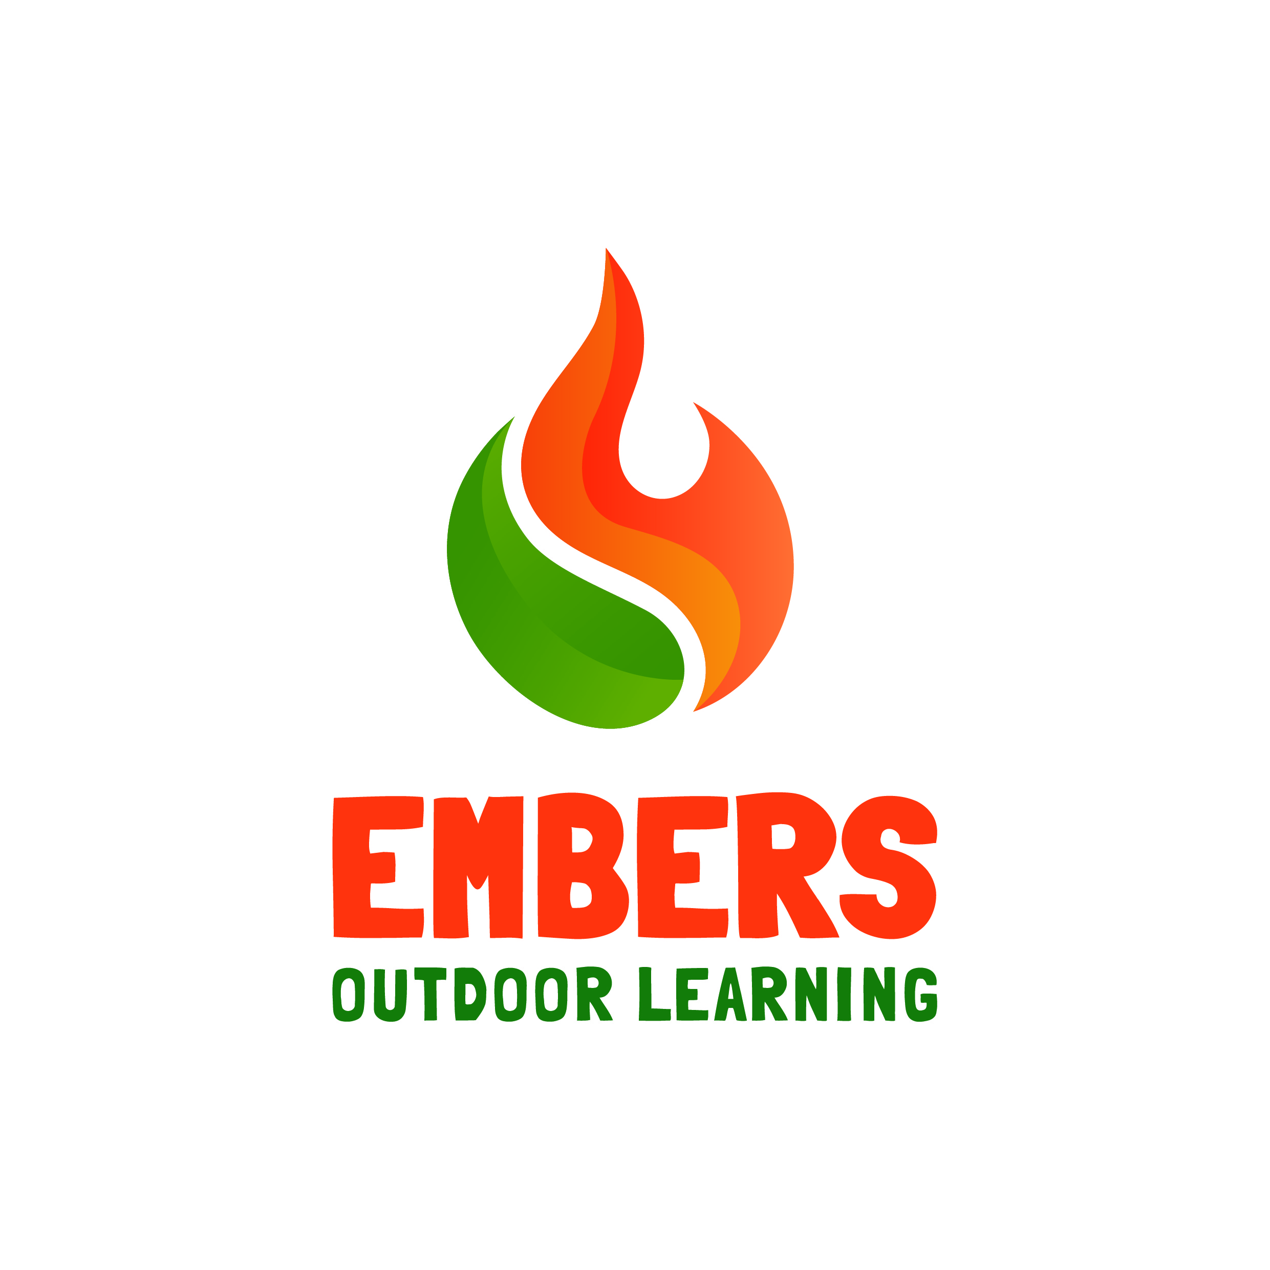 Parental Consent and Medical Form

To be used for children under 18 and adults needing care 18-24.

All information given on this form is confidential and General Data Protection Regulation (GDPR) compliant. This will not be divulged outside Embers Outdoor Learning in any other way than agreed.
Child and parent/guardian - contact details
Child’s Name: |  | Child’s address if different to parent/guardian’s | Address:  Post code:
Child’s date of birth: |  | Child’s address if different to parent/guardian’s | Address:  Post code:
Parent/guardian’s name: |  | Child’s address if different to parent/guardian’s | Address:  Post code:
Parent/guardian’s  address and contact telephone number | Address:  Post code:  Home:  Mobile: | Child’s address if different to parent/guardian’s | Address:  Post code:
Child’s doctor’s contact details
Parent/guardian’s email address:
Mailing list: | Would you like to receive emails about our future events and activities?  We will not share your details with any third parties. Yes No

Child – emergency contacts
Name: |  | Name:
Contact tel. | Home  Work  Mobile | Contact tel. | Home  Work  Mobile
Relationship to child |  | Relationship to child

Child - medical and welfare information
Does your child have any allergies? If yes, please list below.
Has your child been stung by a bee or a wasp? If yes, did they have an adverse reaction?
Does your child have any health problems or require/take medication? If yes, please list below.

Does your child have any other special needs, diets or welfare requirements we should know about?
If yes please list below:

Consent and agreement
For each statement below please circle as appropriate:
I give permission for my child to take part in Embers Outdoor Learning activities.
Yes No
I give consent for Embers Outdoor Learning staff to give emergency first aid and to contact emergency services if needed, for the child named above. Yes No

I confirm, to the best of my knowledge that the medical and welfare information about the child named above is correct. Yes No
I give permission for Embers Outdoor Learning to take photos of my child to be used in promotional and marketing materials such as printed literature and Social Media. Yes No
If the Forest School activity requires parental attendance and supervision, please read and agree to the following statement.
I understand that I am responsible for the supervision and Health and Safety of the child in my care during Forest School activities. Yes No
Embers Outdoor Learning will:
- Explain to you and your child how the Forest School works and your roles in it.
- Make all the relevant policies and procedures available to you.
- Provide a safe environment for activities in line with our Health & Safety Policy.
- Respect your abilities, dignity and individual wishes and do our best to meet them.
- Provide public liability insurance for all participants during Embers Outdoor Learning activities.
- Follow our Equal Opportunities and Safeguarding Children & Vulnerable Adults policies.

We ask participants to:
- Follow our admission, attendance and cancellation policy.
- Follow Embers Outddor Learning’s policies, procedures and guidance while taking part in activities.
- Inform the Forest School Leader of any medical conditions or support needs.
- Tell the leader if you have any problems or questions.
- Treat other participants, members of staff and volunteers with respect.

Basic information on key Embers Outdoor Learning’s policies (full policies available upon request)
Health, Safety & Welfare
It is the duty of Embers Outdoor Learning to ensure, so far as is reasonably practicable, the health, safety and welfare of its participants. All staff, volunteers and participants must comply with the organisation’s health and safety policies.
Insurance
Whilst involved in the Embers Outdoor Learning’s activities participants are covered by the Leader’s Public Liability Insurance Policy. The insurance does not cover personal possessions and participants are advised to make their own arrangements and take precautions as far as their own belongings are concerned.
Safeguarding Children & Adults Needing Care
Embers Outdoor Learning has a duty to safeguard children and vulnerable adults in its care and to protect its staff and volunteers from allegations of abuse. Any member of staff and volunteers who are responsible for unaccompanied children under 18 or adults needing care are asked to provide character references and an up-to-date DBS (Disclosure and Barring Service) check.
Equal Opportunities
Embers Outdoor Learning is an equal opportunities organisation. It will not tolerate harassment and discrimination of volunteers, participants or staff on the basis of race, gender, ethnic background, sexual orientation or disability and will take action to prevent it.
Confidentiality
Embers Outdoor Learning does not share any personal information unless permission has been granted by the data subject or there is an emergency where the health, safety and welfare of the data subject are in jeopardy.

*************************************************************************

Please sign below if you agree with the following statement.

I declare, that to the best of my knowledge, the information given in this form is correct and I know of no reason why my child/group or I should not participate. I consent to the personal details supplied on this form being used within Embers Outdoor Learning. I have received and understand the basic information in the Embers Outdoor Learning’s rules and procedures, including health and safety and equal opportunities and I agree to abide by these.

Print name: ________________________________

Signature: ________________________________ Date: ____________________

